Kali Linux in Basic Commands
Kishan intern id :- 2031

1. pwd – Print Working Directory
Description: Shows the current directory you are in.
Example:
pwd
Output:
/home/kishan/Documents
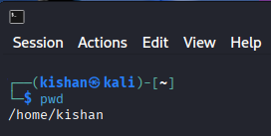

2. ls – List Files and Directories
Description: Displays files and folders in a directory.
Example:
ls
ls -la
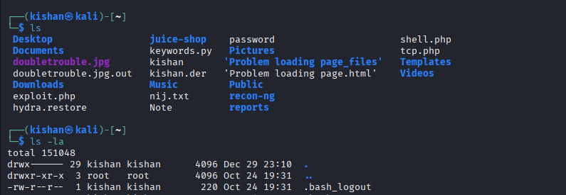

3. cd – Change Directory
Description: Moves between directories.
Example:
cd Downloads
cd ..
cd /etc
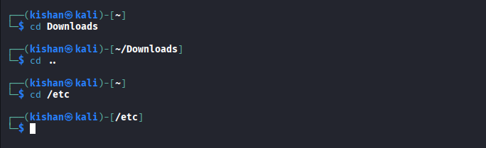

4. mkdir – Make Directory
Description: Creates a new directory.
Example:
mkdir projects
mkdir -p dev/web/app

5. rmdir – Remove Empty Directory
Description: Deletes an empty folder.
Example:
rmdir old_folder
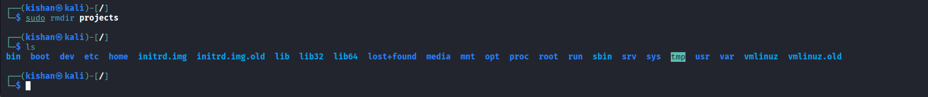

6. touch – Create Empty File
Description: Creates a new empty file.
Example:
touch file.txt
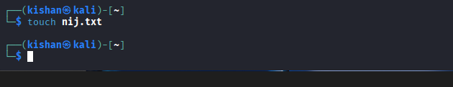

7. cp – Copy Files or Directories
Description: Copies files or folders.
Example:
cp file.txt backup.txt
cp -r folder1 folder2
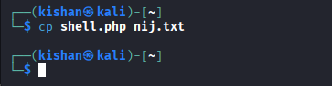

8. mv – Move or Rename Files
Description: Moves or renames files/directories.
Example:
mv file.txt newfile.txt
mv file.txt /home/kishan/
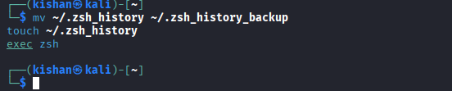

9. rm – Remove Files or Directories
Description: Deletes files or folders.
Example:
rm file.txt
rm -r folder
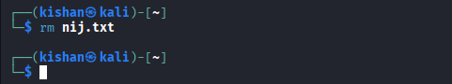

10. cat – View File Content
Description: Displays file content in terminal.
Example:
cat file.txt
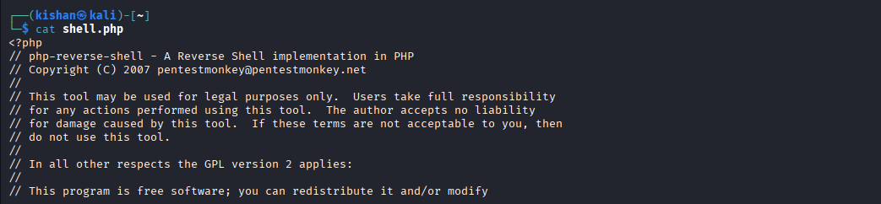

11. less – View File Page by Page
Description: Reads large files safely.
Example:
less file.txt
(Press q to quit)
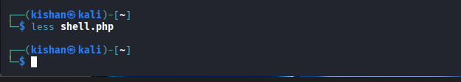

12. head – View First Lines
Description: Shows first 10 lines of a file.
Example:
head file.txt
head -5 file.txt
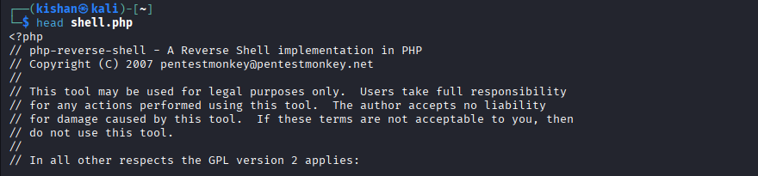

13. tail – View Last Lines
Description: Shows last 10 lines of a file.
Example:
tail file.txt
tail -f log.txt
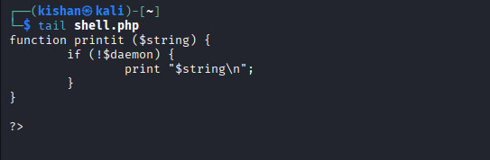

14. echo – Display Text
Description: Prints text to terminal.
Example:
echo "Hello Linux"
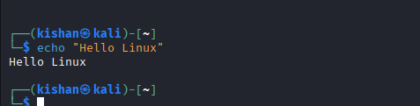

15. man – Manual Pages
Description: Shows help for commands.
Example:
man ls
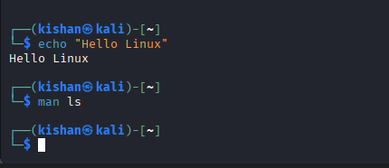

16. chmod – Change File Permissions
Description: Controls read, write, execute permissions.
Example:
chmod 755 script.sh
chmod +x script.sh
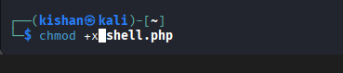

17. chown – Change File Owner
Description: Changes file owner.
Example:
sudo chown user:user file.txt
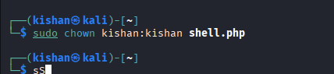

18. df – Disk Free Space
Description: Shows disk usage.
Example:
df -h
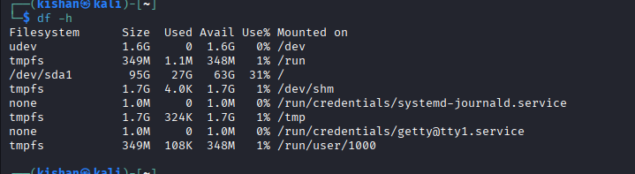

19. du – Directory Size
Description: Displays file or folder size.
Example:
du -h folder
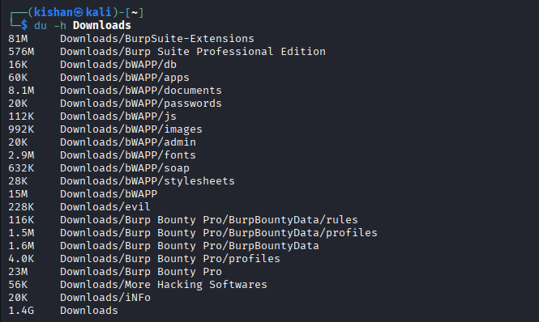

20. free – Memory Usage
Description: Shows RAM usage.
Example:
free -h


21. top – Running Processes
Description: Displays active processes in real time.
Example:
Top
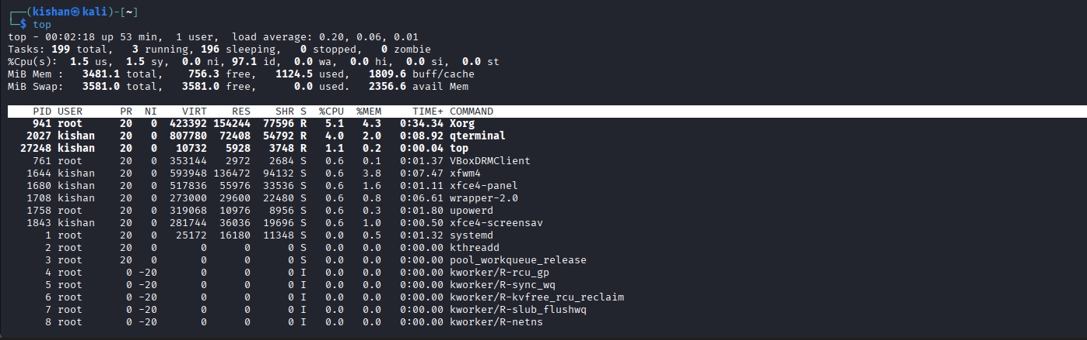

22. ps – Process Status
Description: Shows running processes.
Example:
ps
ps aux
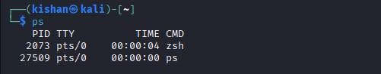

23. kill – Stop a Process
Description: Terminates a running process.
Example:
kill 1234
kill -9 1234
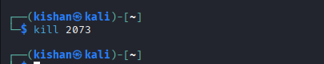

24. whoami – Current User
Description: Shows logged-in username.
Example:
Whoami


25. uname – System Information
Description: Displays OS details.
Example:
uname -a

26. history – Command History
Description: Shows previously used commands.
Example:
History
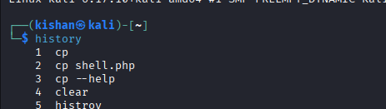

27. clear – Clear Terminal
Description: Clears terminal screen.
Example:
Clear
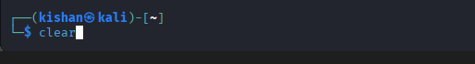

28. wget – Download Files
Description: Downloads files from internet.
Example:
wget https://example.com/file.zip
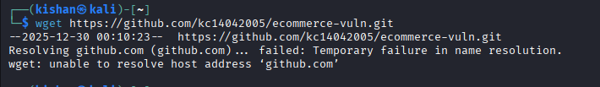

29. curl – Data Transfer Tool
Description: Fetches data from URLs.
Example:
curl https://example.com
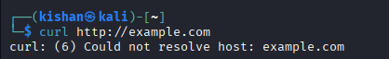

30. sudo – Run as Administrator
Description: Executes commands with root privileges.
Example:
sudo apt update

